Superset Setup

Basic instructions are found here (some modifications were needed – see steps below links)

<https://superset.incubator.apache.org/installation.html>

<https://galaxydatatech.com/2017/10/29/superset-installation/>

<https://www.youtube.com/watch?v=0zhQ52BQQ5s>

# Installation (pip install)

This was tested and worked with Python 3.7.4

After following instructions to create a virtual environment activate it by running…

Use Cygwin terminal

> . ss.bat

After running the batch script, you should see

## Fixes

Next Pip Install packages

You can use **pip install superset** as given in the instructions, but there were some version issues that messed things up. To address, verify:

pandas==0.23.4

sqlalchemy==1.2.14

flask-jwt-extended==3.14.0

click==6.7

flask==0.12.4

flask-appbuilder==1.12.2

To install versions without updating other packages:

> pip install --no-deps --force-reinstall

Example of re-installing sqlalchemy

>python -m pip install --no-deps --force-reinstall --trusted-host pypi.python.org --trusted-host files.pythonhosted.org --trusted-host pypi.org sqlalchemy==1.2.14

# Create an admin user

>fabmanager create-admin --app superset

If successful should see the green confirmation message

# Launching

Once correct package versions are installed you can launch

Make sure the virtual env is active and you are in the Scripts folder

# Initialize the database

>python superset db upgrade

# Load some data to play with

>python superset load_examples

# Create default roles and permissions

>python superset init

# Start a development web server on port 8088

>python superset runserver -d

Go to your web browser and enter: localhost:8088/login/

Enter username and password set above in create-admin step

Click on Dashboards tab at top

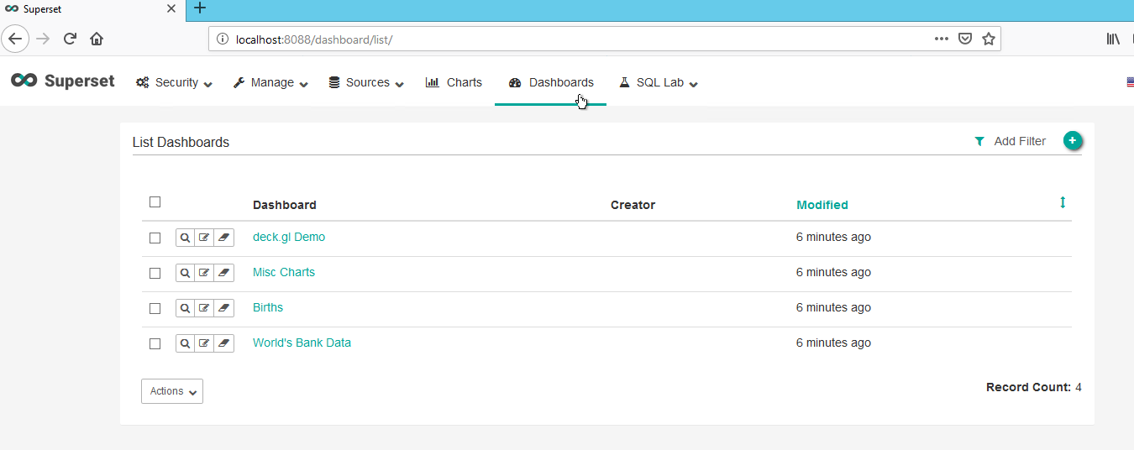

# Add a database (SQLite)

Click on Sources tab at top

Select Databases

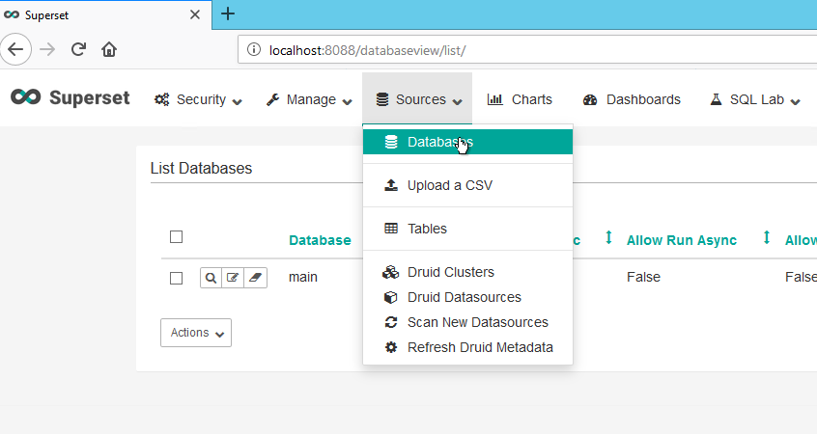

Click on the plus (=) sign on upper right hand side to add a connection

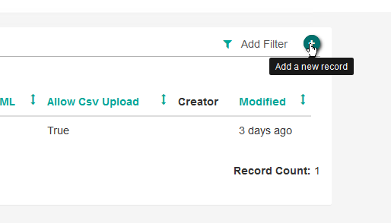

Fill in the following fields:

Database: give it a name

SQLAlchemy URI: e.g., sqlite:///path to database

Click Test connection to make sure okay

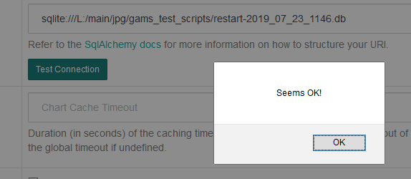

Expose in SQL Lab: Check to allow

Allow CSV Upload: Check Allow CSV upload

Scroll to bottom of page and click Save

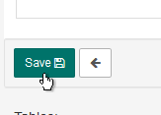

You should be taken to List of Databases where you can see your SQLite database was added

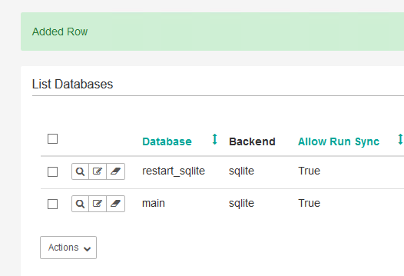

# Add a table from database

<https://shuaiw.github.io/2017/08/26/building-beautiful-dashboards-with-superset.html>

# Starting without loading example set

Superset uses the Flask-AppBuilder framework (fabmanager) to store and manage data for authentication, user permissions, and user roles in Superset.

We use the create-admin command in fabmanager and specify Superset as the app.

The Flask-AppBuilder framework will create a metadata database using SQLite by default in the ~/.superset location

Skipping this step will prevent logging in.

>fabmanager create-admin --app superset

After creating the admin user for the Superset app, we have to run the following commands to create tables and update columns in the metadata database:

# Initialize the database

>python superset db upgrade

# Create default roles and permissions

>python superset init

Finally, start Superset web server on port 8088

>python superset runserver -d

Open the web app in your browser localhost:8088/login/

and log in with the admin credentials you entered when using the create-admin command on fabmanager

If you click on the Sources tab then Databases you should see you’re default sqlite database backend.